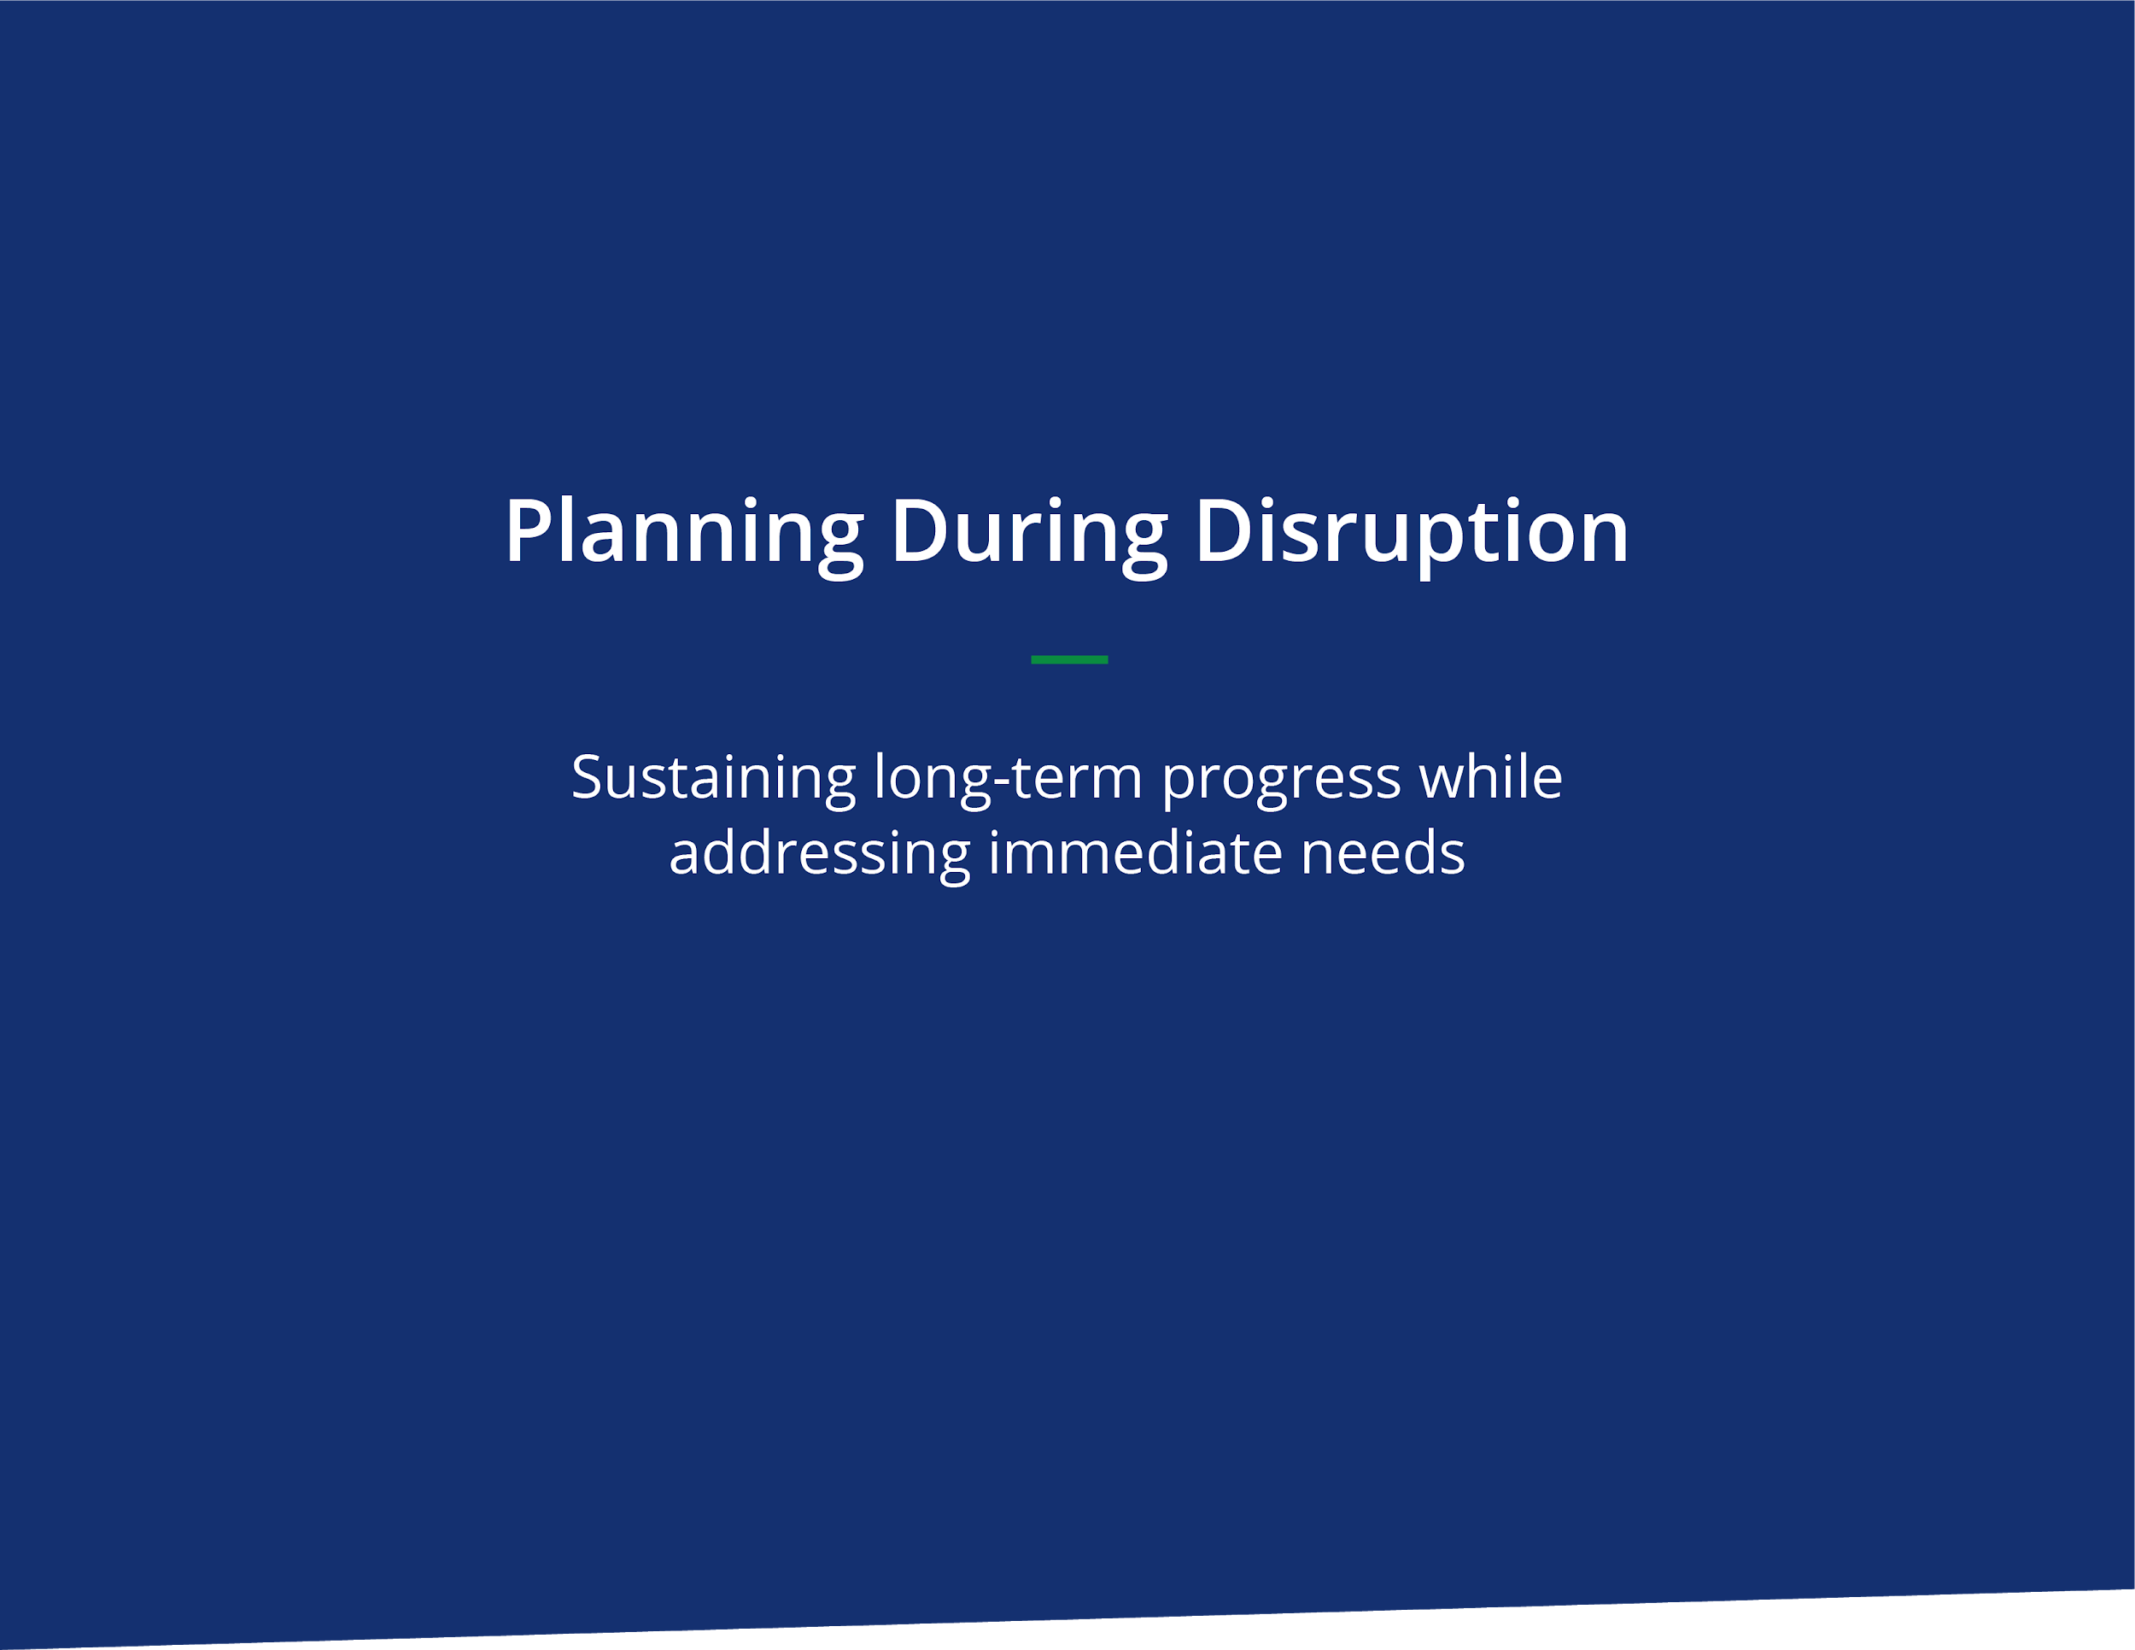
Planning During Disruption
Sustaining long-term progress while addressing immediate needs
Context: What is the disruption? How is it changing our clients and community?:
Focus: What’s our area of focus for our planning?:

Contingency Planning | Leveraging Change | Seizing Opportunities
Immediate: What must we change now to make it through this disruption, mitigate risk, and sustain ourselves? | Short term: Which tactics might we continue or leverage to improve our work or to help us meet strategic goals and mission? | Long term: Which changes, if scaled, present strategies for faster progress? What new opportunities have emerged that we should address?
Immediate intended result: | Short term intended result: | Long term intended result:
Do  Do | Do  Do | Do  Do
Pause | Pause or Stop | Stop
Protect or sustain | Protect, sustain, or bring back | Protect, sustain, or bring back

Planning During Disruption
Guidelines for Using/Facilitating

Purpose:
This tool is designed to help leaders explore ways to sustain long-term progress towards important goals while addressing immediate changes required by disruptions. This tool is not designed to serve as an emergency response plan to protect your clients, customers or employees. Instead, this is a tool to consider the longer-term effects, opportunities and side effects of your short term choices.

Instructions:
Use this template with a leadership team, department staff, board of directors, or on your own.

The time required is flexible. 20 mins will help you start the conversation and name some basic information. 90 minutes would likely be enough time for a small group to make a strong plan.

Steps:
- Name the disruption on which you are focusing.
- Name the area of focus. This could be the entire organization or a department: (e.g. Human Resources, Program, Technology, Production, Services, Supply Chain, Marketing, etc.)
- In the left column name the changes you are making right now. What do you need to do, pause, or protect? What results do you expect in the short term?
- In the middle column consider how the short term changes can be leveraged for experimentation, learning, or growth. These might be linked to the first column or might be tactics that are unrelated.
- In the last column discuss strategies for long term progress and elements that you must not lose along the way.
- Finish the session with an agreement on next steps, and a commitment to a pattern of reflection on these items. When is the next time you look at this document and share what's changed and what you've learned.
- Alternative: Begin on the right with long term goals/strategy, and work to the left to connect today’s changes with your aspirations.
EXAMPLE: Planning During Disruption
Sustaining long-term progress while addressing immediate needs

Context: What is the disruption? How is it changing our clients and community?: Covid-19 is making it difficult for clients to meet with us. We are at home. Clients are consumed by pressures at home and work. People are fearful about the virus and uncertainty.
Focus: What’s our area of focus for our planning?: Client services

Contingency Planning | Leveraging Change | Seizing Opportunities
Immediate: What must we change now to make it through this disruption, mitigate risk, and sustain ourselves? | Short term: Which tactics might we continue or leverage to improve our work or to help us meet strategic goals and mission? | Long term: Which changes, if scaled, present strategies for faster progress? What new opportunities have emerged that we should address?
Immediate intended result:  Help our currents stabilize in any way we can. Keep contact. | Short term intended result: Provide real value during disruption, especially through facilitation and coaching leaders | Long term intended result: Creating new value propositions and models for the organization.
Do  Quickly, gather, develop and deploy resources to support our clients during this crisis. (Virtual facilitation, planning tools)  Do  Upgrade and add virtual technology. Identify and practice creative engagement virtually to help our clients succeed. | Do  Speed up our communication cadence  Do  Continue highlighting the value of visual and creative facilitation that engages people -- even virtually. | Do  Offer workshop, public course on virtual facilitation or a subscription service for our process for visual facilitation  Do  Provide coaching to senior leaders to help them design high impact moments.
Pause  Stop traveling. Stop meeting face to face. | Pause or Stop  Reduce travel. Save resources for our clients. | Stop  Hiding the value of facilitation inside other products.
Protect or sustain  Our commitment to our client’s long term goals and endeavors even as this work becomes less urgent. | Protect, sustain, or bring back  Living within the boundaries of the contracts and communicating changes with our clients | Protect, sustain, or bring back  A commitment to deep engagement with our core clients, not “just” technical skill building.

